The Enhanced Greenhouse Effect
Multiple Choice
- State a common type of fuel before the Industrial Revolution.
- Uranium
- Charcoal
- Batteries
- Coal

- State the preferred fuel during the Industrial Revolution.
- Water
- Uranium
- Coal
- Charcoal

- Recall why burning coal is worse than burning charcoal.
- The carbon in coal is in a much slower part of the cycle.
- The carbon in coal is outside of the carbon cycle.
- The carbon in charcoal is made from trees.
- The carbon in charcoal is naturally occuring.

- Explain how increased coal use marked the beginning of the enhanced greenhouse effect.
- Making charcoal was a carbon sink.
- Burning coal releases stored carbon dioxide.
- Coal burns much hotter than charcoal.
- People started making more greenhouses.

- What name refers to the intensification of the greenhouse effect due to human activity?
- The greenhouse effect
- The incredible greenhouse effect
- The enhanced greenhouse effect
- The improved greenhouse effect

- Recall why carbon is accumulating in the atmosphere.
- Humans have introduced more carbon sources than carbon sinks.
- Humans have introduced more carbon sinks than carbon sources.
- Humans have found carbon sources outside the carbon cycle.
- The atmosphere is absorbing carbon from space.

- List two ways we can reduce the enhanced greenhouse effect.
Select two options
Select ALL correct options
- Reducing carbon emissions
- Increasing carbon sinks
- Not making more greenhouses
- Burning wood instead of charcoal

- Recall what someone means when they say "humans are causing the greenhouse effect".
- "Humans are causing the enhanced greenhouse effect"
- "Humans are causing the glasshouse effect"
- "Animals are causing the greenhouse effect"
- "Humans are not causing the greenhouse effect"

- Recall how long carbon dioxide can remain in the atmosphere.
- 1 year
- 10 years
- 100 years
- 1000 years

- State which of the following is the main man-made source of carbon dioxide.
- Making solar panels
- Using fertilisers
- Breathing too deeply
- Burning fossil fuels

- Recall the main man-made source of atmospheric methane.
- Fossil fuels
- Volcanoes
- Livestock
- Fertilisers

- Recall how long methane can remain in the atmosphere.
- 1 year
- 10 years
- 100 years
- 1000 years

- Recall the second biggest man-made source of methane.
- Coal mines
- Politicians
- Corn fields
- Rice paddles

- Recall the main man-made source of nitrous oxide.
- Using fertilisers
- Drag racing
- Dentistry
- Burning fossil fuels

- State how long nitrous oxide can remain in the atmosphere.
- 1 year
- 10 years
- 100 years
- 1000 years

- List TWO things that CFCs were originally used for.
Select ALL correct options
- Automobiles
- Refrigerators
- Fertilisers
- Aerosol sprays

- Recall how long CFCs can remain in the atmosphere.
- Days
- Months
- Years
- Hundreds of years

- Identify which greenhouse gas is produced when we burn fossil fuels.
- Methane
- CFCs
- Carbon dioxide
- Nitrous oxide

- Identify which greenhouse gas is produced by livestock and rice paddies.
- Methane
- Carbon dioxide
- Nitrous Oxide
- CFCs

- Identify which greenhouse gas sees increased production due to fertiliser usage.
- Nitrous oxide
- CFCs
- Carbon dioxide
- Methane

- Identify which greenhouse gas is no longer used due to the damage it does to the ozone layer.
- Carbon dioxide
- CFCs
- Nitrous oxide
- Methane

The following questions uses the below graph.
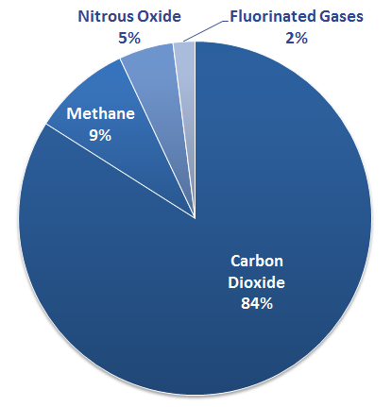
- This graph shows human greenhouse gas emissions.
State how many different greenhouse gases humans produce.
- 1
- 2
- 3
- 4

- This graph shows human greenhouse gas emissions.
Select the option that is not shown on this graph.
- Methane
- Fluorinated gases
- Carbon dioxide
- Nitrogen dioxide
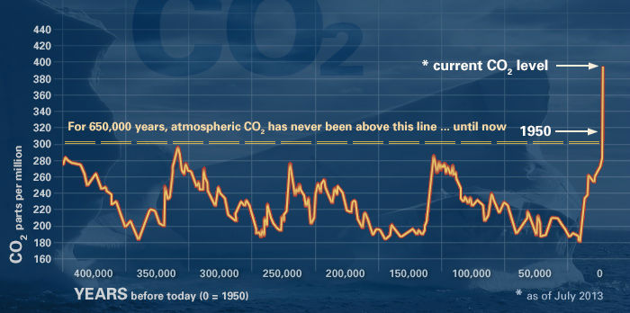

This graph shows atmospheric carbon dioxide levels over the last 400,000 years.
Use this graph to select which of the following statements are true.
- CO₂ levels cannot be measured.
- CO₂ levels are currently part of a regular cycle.
- CO₂ levels are higher than they have been in over 400,000 years.
- CO₂ levels are due to drop within the next few years.

